**ELO 5**

**FJ Fourie 26047799**

**REII 327**

**NET 1 BIER**

Revision 2

October 23, 2017

Table of Contents

3. Member – ELO 5 Report 1

3.1 Scope of work: 1

3.1.1 Documentation 1

3.1.2 Research 1

3.1.3 Project management 1

3.1.4 Design 2

3.2 Assumptions and Constraints: 2

3.3 Discipline-Specific Engineering Methodology: 3

3.4 Simulations / Flowcharts and Other designs: 4

3.5 Physical Tests / Measurements: 6

3.6 Health and Safety Considerations: 7

3.7 Discussion of Tools Used to Enhance Productivity: 7

4. Sub-system Specifications Document Error! Bookmark not defined.

4.1 Sub-system Functional Analysis Error! Bookmark not defined.

4.2 Sub-system Interface Definitions Error! Bookmark not defined.

**List of Figures:**

Figure 1: Database Design 4

Figure 2: Protocol Design 5

Figure 3: Flow chart of program 6

# Member – ELO 5 Report

# Scope of work:

My work for this project is divided into 4 categories which are Documentation, Research, Project management and technical

# Documentation

* Help with the teams’ design portfolio
* Complete my individual ELO 5 document
* My individual section of the Excel document
* Help with the team part of excel document
* Datasheets and application notes used

# Research

* How the QT programming environment works
* Research on C++ programming language
* Creating a gui in QT
* Creating a database using MYSQL
* Publishing a database to a server using MYSQL
* Connecting a published database to a program

# Project management

* Ensure that everyone in the team know what they must do at all times
* Ensure project stays on track and will be finished on time
* Identify and keep track of all risks as they appear and address all these risks adequately
* Hold meetings to make sure everyone is on the same page

# Design

* Program design in the form of a flow chart showing logical flow of program
* Database design as in MYSQL showing all relations
* Make sure that the program is compatible with database and communication is possible
* Design backend program to meet all requirements such as safety
* Design backend to be easily integrated with rest of project
* Design the protocol that will be used for the transmission of data between alarm panel and backend

# Assumptions and Constraints:

Thru working on the project and following the methodologies and tools provided by ELO 5 it has become clear that the project has some assumptions and constraints. The first assumption that was made is that the back end operator is not very good with computers and my not always follow instructions precisely. With the first assumption comes two constraints firstly that the program needs to be user friendly since the operator may not be good with computers and secondly the program needs to force the operator to follow the correct procedure before being able to turn of the alarm off or mark the alarm as resolved since he may not want to follow procedure. The second assumption made was that junk data could be received if something was to go wrong with connection to user end considering the user connects wirelessly to network plus there is the possibility of tampering. This led to a constraint in the form that network communication link needs to be monitored and an event needs to be triggered if communications with end user cannot be established for a certain amount of time. The Next constraint that I have identified up until now is that I need to ensure the programming environment and language used to code in can easily be integrated and used with the database. A constraint that was identified was that the coding language also needs to be the same coding language as the code written on the SoC to help with integration. The assumption that the project will be complete before the deadline has the constraint that the semester is loaded with work off other modules with more immediate hard deadlines thus time to spend on the project is very limited. An assumption that the project will be complete before the exam to ensure it does not interfere with studying for exams has the constraint of very limited time before the exam due to a very short semester and a lot of work in other modules.



# Discipline-Specific Engineering Methodology:

In order to complete the required tasks certain systems and methods where used to speed up the process and to make it easier to complete it satisfactory. These systems and methods are things such as Flowcharts, UML diagrams, FSM diagrams, Protocol designs and functional analysis. These tools make it easy for the engineer to plan the structure and logic flow of his program and system before he starts programming it. These tools also have the added benefit to help outsiders understand how the program works and how the system functions without the need to know or understand the physical code. It also helps with integration of the system as other engineers working on other parts of the project can clearly see what your system needs as input or what it will give as output.

I made use of a flowchart to design and plan my program for the backend of the alarm system, the flowchart indicates the logical flow of the program as well as the planned features and how they will be integrated to which parts of the program. This also makes it possible for me as programmer to keep track of what I have done and which parts still needs to be done and by keeping track of what is completed it can easily be seen what still needs to be done. A UML diagram was used to show the design of the classes of the program a UML diagrams where also used for the database that will be used to store the data of clients as well as the data of events that have happened in the past, the login credentials of users will also be stored in a separate database that is also indicated with a UML diagram. The UML diagram is also to keep track of which classes and parts of the program is finished as well as in the case of the database to easily know and see how everything connects and makes it easier to work with the database in the program. There was made use of a protocol design to establish the agreed upon data packets that will be transferred between the alarm panel and the backend, this establishes in what order the data will be sent as well as what data will be sent, there are also agreements on parity bits and other safety features. The functional analysis was done to indicate the general working and flow of the project and how and where everything fits in it is a necessary part to do at the start of any project to get a general overview of the project.

# Simulations / Flowcharts and Other designs:

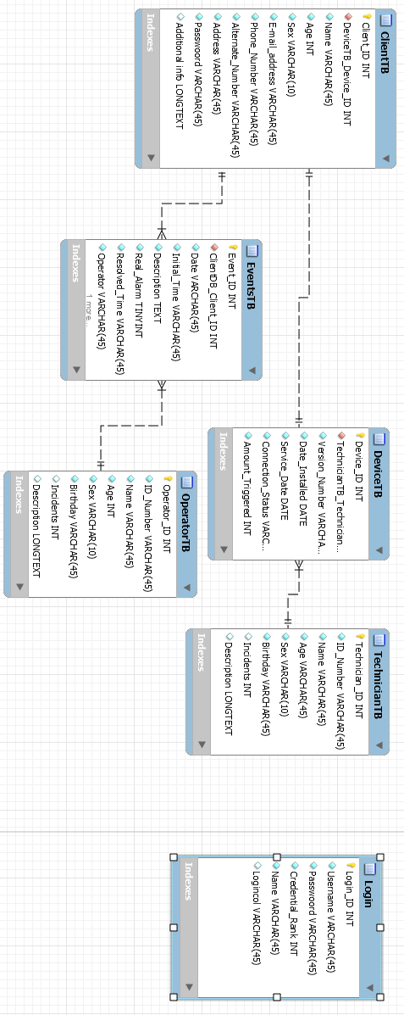

Figure : Database Design

In the above Figure 1 all the table in the database is shown as well as all the relationships between these tables. Each entry in each tables type is indicated after its name as well as primary keys are indicated with a key before the name, Foreign keys are indicated with a red diamond before there name and the entry’s that may not be null is indicated with blue diamonds before their names.

Transmission Control Protocol, TCP, to be used to send data from Panel to backend services.

Payload protocol fields;

|  |  |  |  |  |  |
| --- | --- | --- | --- | --- | --- |
| Protocol ID (‘1B’) | Client ID | Date | Time | Section code | Parity |

Figure : Protocol Design

Above in Figure 2 it shows the protocol that will be used and the data fields. This is the agreed upon protocol that will be used for the transmission and receiving of data. The payload fields will be “#” separated.

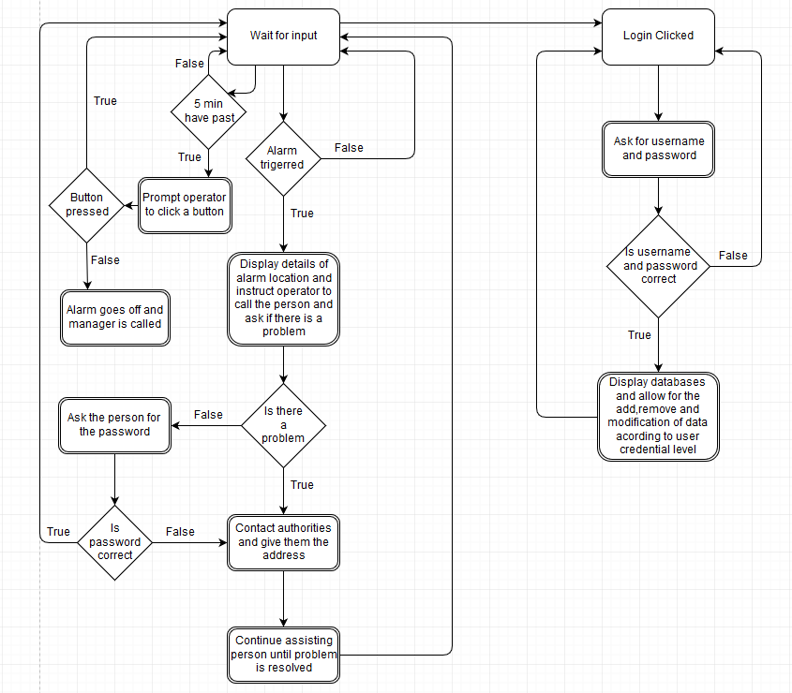

Figure : Flow chart of program

In the above Figure 3 the flow chart of the program is shown which shows the logical flow and major functions of the program that will be used for the backend program.

# Physical Tests / Measurements:

To ensure the backend works as intended and that all functionality is present the program and database will be tested by letting a few people work with it and attempt to break it, also people not good with computers will be asked to test it to see if it is the desired level of user friendly these tests will be done when the program is complete. There will also be self-tests to see if the desired code modules do as plan and that each module works correctly these self-tests will be done thru out the development process. We will also tamper with the user end and ensure the backend responds correctly to the different scenarios.

# Health and Safety Considerations:

With this project it needs to be remembered that it is a security system involved and thus is responsible for people’s safety and wellbeing. The backend of the project needs to ensure that the right procedures are followed and are executed swiftly to ensure people receive help fast when needed. For all these reasons the backend needs to be created so that signals and alarms aren’t missed and that help can be easily and quickly contacted when needed. To ensure the safety of the user the backend will also need to be able to detect when the communication link is broken or when there is tampered with user end so that help can be contacted. We also need to ensure backend up time thus we will have a backup computer in case the primary computer fails. The health and safety of the operators also needs to be taken into consideration to ensure an operator doesn’t fall asleep at the station or leaves the station thus leaving the backend unmanned thus procedural checks will be implemented to ensure the operator is awake and at his station when he should be. We will also need to have at least two operators at all-time in case of multiple alarms and to allow the operators to take breaks every now and again so that there is still one operator at the station when one takes a break. Bylaw 25 will also be followed during the design of the project.

# Discussion of Tools Used to Enhance Productivity:

To ensure maximum productivity certain tools where used to help me accomplish tasks easier and faster with more accuracy, without many of these tools certain aspects of this project would not be accomplishable or at least have been much harder than necessary.

The first set of tools used are the documentation tools. The first documentation tool used was Microsoft Word this tool was used to create the design portfolio in a neat manner and to present it in an aesthetically pleasing and professional form. This tool also made formatting and referencing as well as creating table of contents and table of figures much easier than would have otherwise have been. We then used the Acrobat reader to ensure that everything in the design portfolio still looked correct and was correctly formatted after we converted the Word document to a PDF format using Word. This conversion was made to protect the integrity of the file as well as make it easier to read on all devices and systems. Microsoft Excel was used for the Excel document of the project to keep track and record of the project management process. The draw.io website was used to create the flowcharts and functional analysis of the project as the website allows better and more professional design of such charts than Word. GitHub was used to back up the program and keep track of different versions and changes in the program throughout the development process allowing easy revision and rollback if necessary. The QT programming environment was used which is an easy to learn environment which provides lots of necessary functionality such as gui design and software interrupts that are easily used and implemented with the C++ programming language. MYSQL was used for the database design and to connect the database to a server. The different MYSQL sub programs made this very easy and seamlessly integrate with one another such as using MQSQL server to host the database and MYSQL workbench to design the database and then you can use the built in functionality of MYSQL workbench to easily connect the database to the MYSQL server. All these different parts of MYSQL have saved a lot of time and effort by doing the integration for me.